Association Rules

Instructions:
Please share your answers filled in-line in the word document. Submit code separately wherever applicable.

Please ensure you update all the details:
Name: __G Rupak___________ Batch ID: __07/05_________
Topic: Association Rules

Grading Guidelines:
1. An assignment submission is considered complete only when correct and executable code(s) are submitted along with the documentation explaining the method and results. Failing to submit either of those will be considered an invalid submission and will not be considered for evaluation.
2. Assignments submitted after the deadline will affect your grades.

Grading:
Ans | Date |  |  | Ans | Date
Correct | On time | A | 100
80% & above | On time | B | 85 | Correct | Late
50% & above | On time | C | 75 | 80% & above | Late
50% & below | On time | D | 65 | 50% & above | Late
 |  | E | 55 | 50% & below
Copied/No Submission |  | F | 45

- Grade A: (>= 90): When all assignments are submitted on or before the given deadline.
- Grade B: (>= 80 and < 90):
  - When assignments are submitted on time but less than 80% of problems are completed.
(OR)
  - All assignments are submitted after the deadline.

- Grade C: (>= 70 and < 80):
  - When assignments are submitted on time but less than 50% of the problems are completed.
(OR)
  - Less than 80% of problems in the assignments are submitted after the deadline.

- Grade D: (>= 60 and < 70):
  - Assignments submitted after the deadline and with 50% or less problems.

- Grade E: (>= 50 and < 60):
  - Less than 30% of problems in the assignments are submitted after the deadline.
(OR)
  - Less than 30% of problems in the assignments are submitted before the deadline.

- Grade F: (< 50): No submission (or) malpractice.

Hints:
- Business Problem
  - What is the business objective?
  - Are there any constraints?
- Work on each feature of the dataset to create a data dictionary as displayed in the below image:
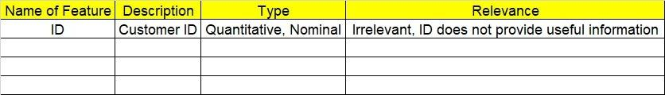

- Data Pre-processing
  - Data Cleaning, Feature Engineering, etc.
- Model Building
4.1 Application of Apriori Algorithm
  - Build most frequent item sets and plot the rules
  - Work on Codes
5.Deployment
5.1 Deploy solutions
6. Write about the benefits/impact of the solution - in what way does the business (client) benefit from the solution provided?

Problem Statement: -
Kitabi Duniya, a famous book store in India, which was established before Independence, the growth of the company was incremental year by year, but due to online selling of books and wide spread Internet access its annual growth started to collapse, seeing sharp downfalls, you as a Data Scientist help this heritage book store gain its popularity back and increase footfall of customers and provide ways the business can improve exponentially, apply Association RuleAlgorithm, explain the rules, and visualize the graphs for clear understanding of solution.
1.) Books.csv

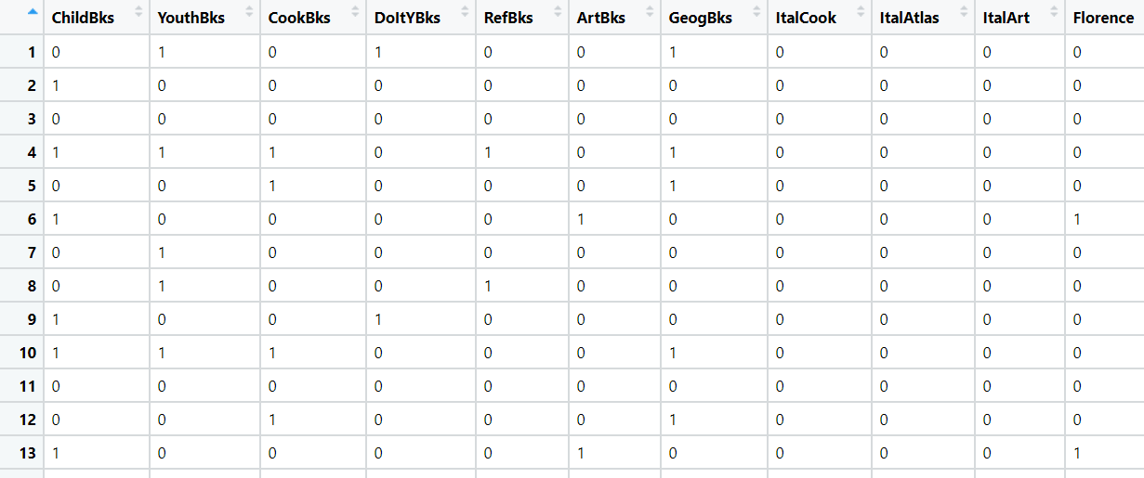

Bussiness Objective :- Increase footfall of customer
constraints :- lack of selling books offline due to online stores.

Rules:-

the most and frequently buyed books are child books and cook books. They both have the hightest support independently as well as constituently .

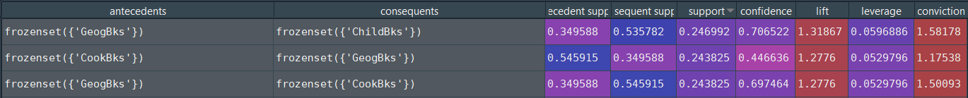
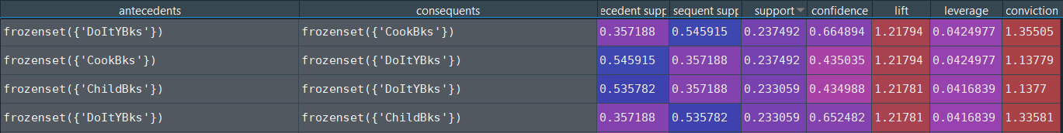

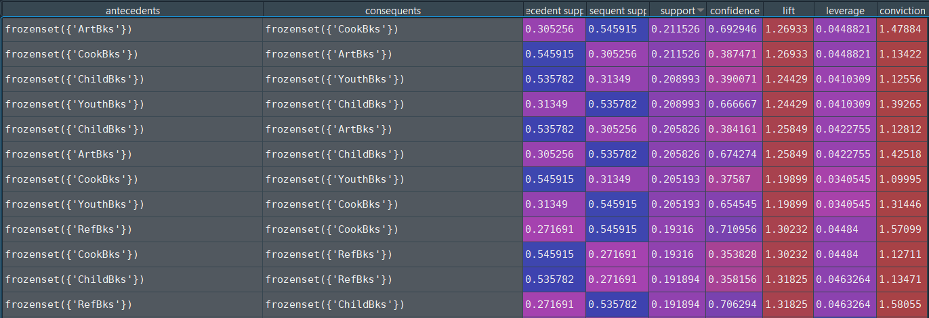

1.As you you can see from above rules if some one buyes geography books,DoItY books,youth books,Art books ND Refbooks they are likely to buy cook books and child books .
2.Are we can also say cooks and child books are most likely to buy as compared to other books.
3.they you can se from in support and confidence column. as well as in lift which is more than 1 which says that consequents are most likely to be buyed than antecedents.
4.there are books which are less likely to be brought are Florence ,intalian cook book,Itart and it atlas . They are the mimimun individual support items.

Deployment:-
1.A book store which is established before independence day it would be pretty much famous in local areas.
It will be very easy to establish partnerships with schools and colleges to recommend their students to buy their study related books from kitabi duinya store only.
2.Conducted exhibition in schools to sell various types of books.
3.Distributing flyers and sticking banners in front of educational institutions .
Benefits:-
1. Booost in sells
2. scools and colleges are best places to attract customers.

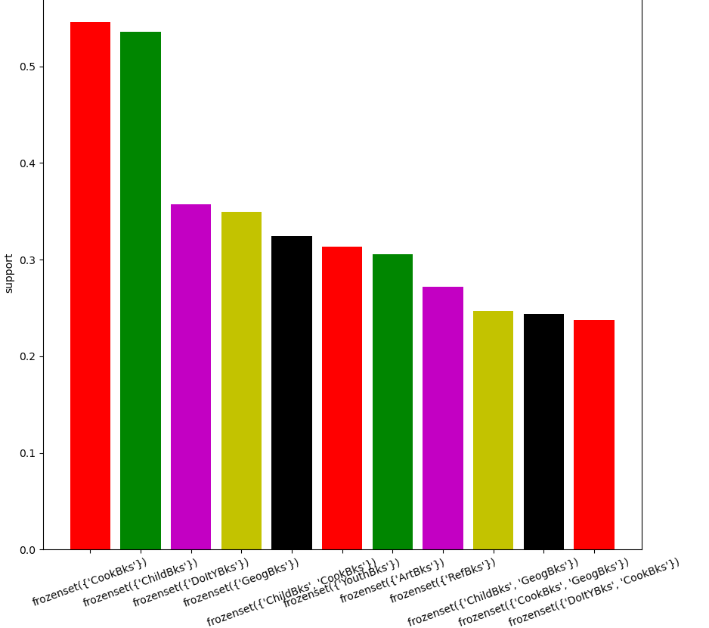
Some of purchase pattrens are ex:-

1.The most popular transaction was of child books and cook books.
2.Another popular transaction was of doItY books ,Geography books, youth books and art books.

Problem Statement: -
The Departmental Store, has gathered the data of the products it sells on a Daily basis.
Using Association Rules concepts, provide the insights on the rules and the plots.
2.) Groceries.csv
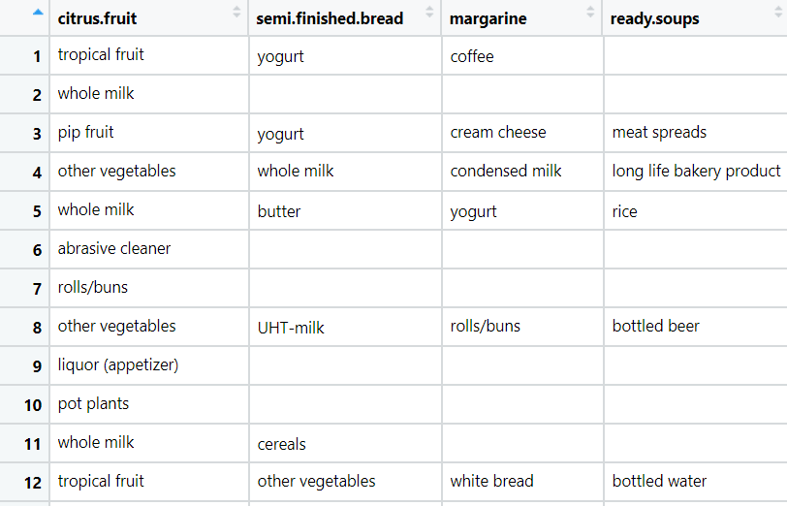

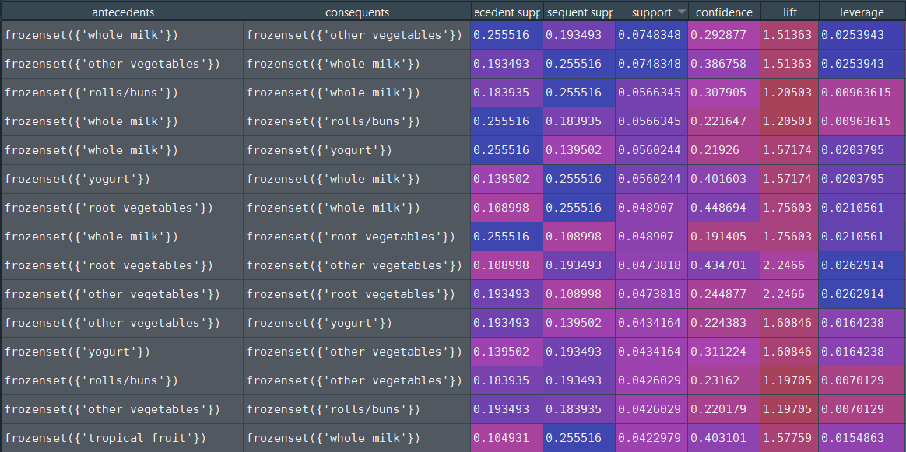

1.Support :- tells about the popular item sets which you can see from above screen shot
some of are whole milk and vegetable are the highest purchased item
2.Leverage :- tells about the item sets that appear together and which are dependent on each other.if leverage value is o(zero) that means those items are independent.

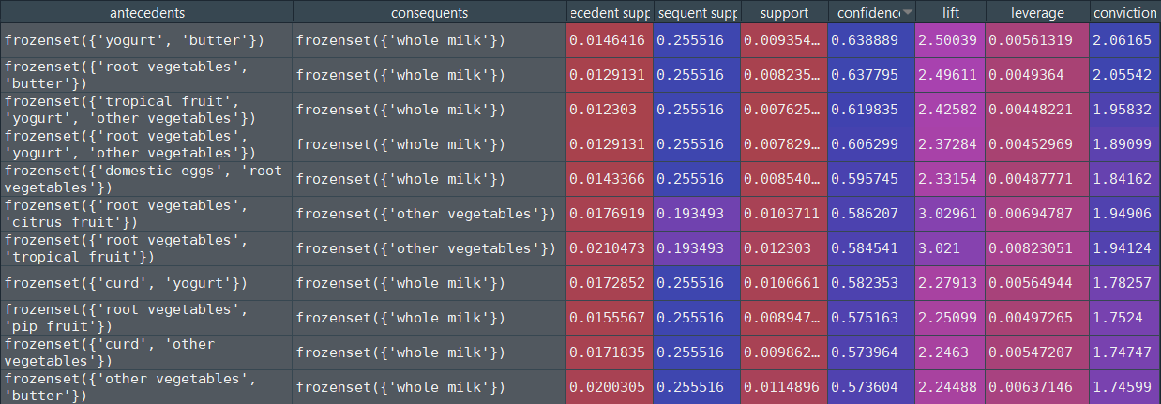
1. Confidence:- saays that how likey consequent is purchased when antecedents is purchased .
a. when some one buys yogurt & butter they definitely buy milk
b.if someone buys fruits they buy vegetable as well

2. Conviction :- a high value of conviction means that consequent is highly depending on
antecendents.

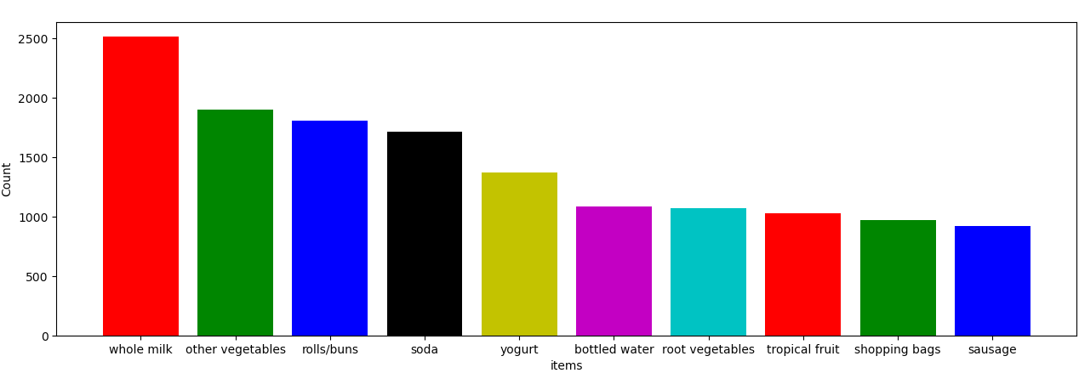

Some of the popular purchases from the above bar plot
1.the most popular purchase is whole milk.
2. other popular transaction is vegetables.
3. Rools and buns are the third most purchased
4. lest purchased item is baby food.

Problem Statement: -
A film distribution company wants to target audience based on their likes and dislikes, you as a Chief Data Scientist Analyze the data and come up with different rules of movie list so that the business objective is achieved.
3.) my_movies.csv
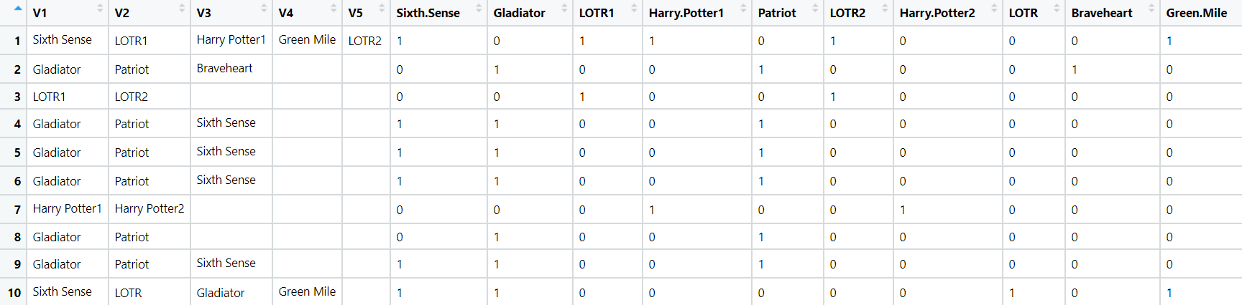

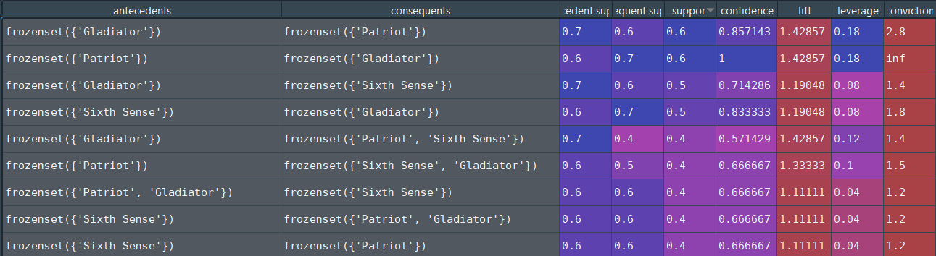
1.If some watch gladiator they also watch patriot and sixth sense also

2.As you can see conviction and confidence is showing 1 and inf means they says that A and C are independent but confidence and conviction has drawback which misrepresents the importance of an association . But from lift if lift value greater than 1 means that C is likely to be watched if if A is watched.
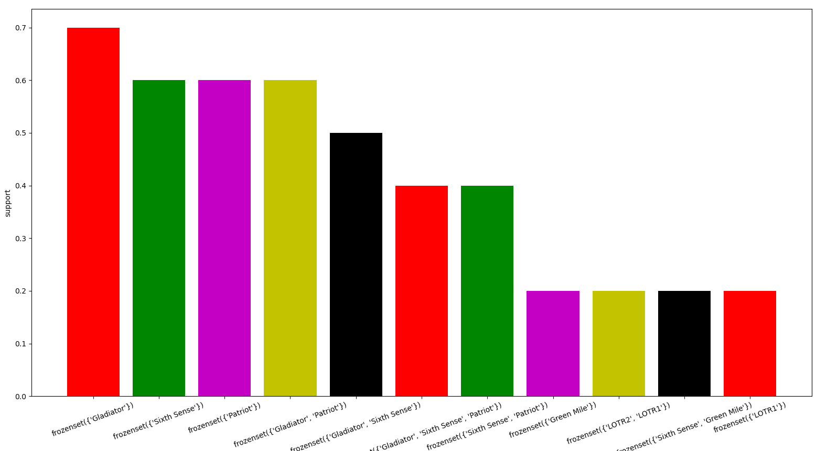

Some of most liked movies
1.Gladiator most watched
2. 2nd most watched movies are patriot and sixth sense
3. gladiator and patrioit are action and adventure movies which people like most.
4. gladiator and sixth sense which are action and horror movie so people like to watch action and bit horror movie.

Problem Statement: -
A Mobile Phone manufacturing company wants to launch its three brand new phone into the market, but before going with its traditional marketing approach this time it want to analyze the data of its previous model sales in different regions and you have been hired as an Data Scientist to help them out, use the Association rules concept and provide your insights to the company’s marketing team to improve its sales.
4.) myphonedata.csv

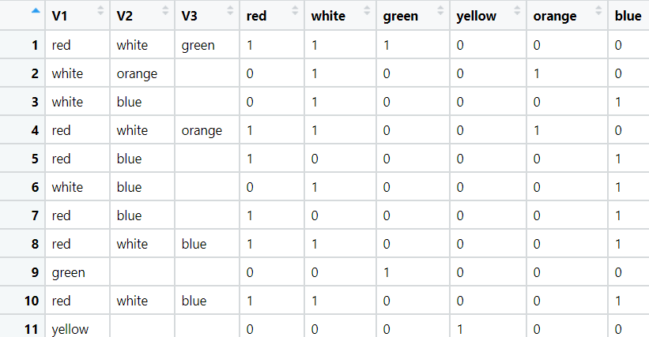

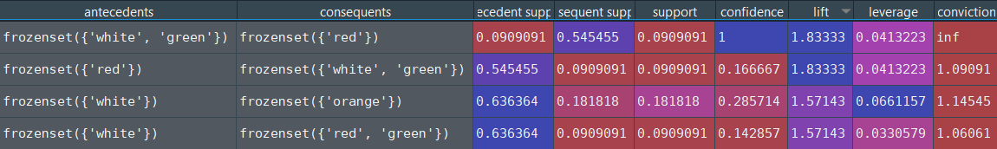
1.although confidence is the misrepresents the association but from lift we can say that when some person buys white and green they also buy red.

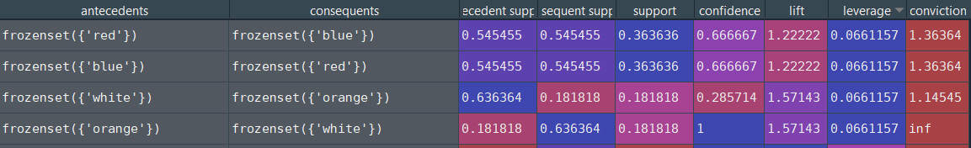
1. from leverage we can see which the A & C are largely dependent
are red and blue , white and orange.

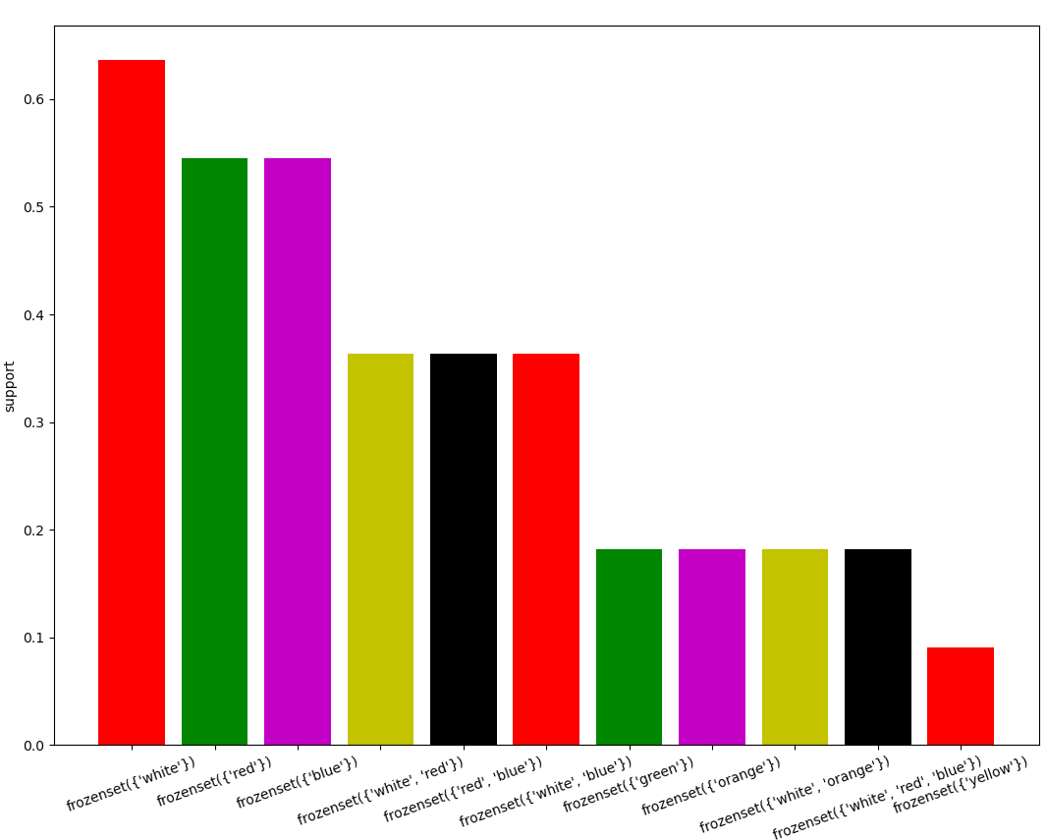

Most popular colours are
1. white the most popular one
2. 2nd red and blue.
3 .here are the association of white , red and red, blue which are frequently buyed together.

Problem Statement: -
A retail store in India, has its transaction data, and it would like to know the buying pattern of the
consumers in its locality, you have been assigned this task to provide the manager with rules
on how the placement of products needs to be there in shelves so that it can improve the buying
patterns of consumes and increase customer footfall.

5.) transaction_retail.csv

